PLAN DE APOYO 2019, GRADO 10°
Indicadores: Identifica y emplea los condicionales en situaciones irreales e hipotéticas en forma oral y escrita.

Expresa arrepentimiento empleando el tercer condicional en forma oral y escrita.

Brinda consejo a problemas cotidianos empleando el segundo y tercer condicional en forma oral y escrita.

Reconstruye una historia empleando el tercer condicional en forma escrita.

Complete the Conditional Sentences (Type II) by putting the verbs into the correct form.

1. If we (have) __________ a yacht, we (sail) ____________ the seven seas.
2. If he (have) ________ more time, he (learn) ______________ karate.
3. If they (tell) ________ their father, he (be) ________________ very angry.
4. She (spend) _____________ a year in the USA if it (be) __________ easier to get a green card.
5. If I (live) ______ on a lonely island, I (run) _____________ around naked all day.
6. We (help) _____________ you if we (know) _____ how.
7. My brother (buy)______________ a sports car if he (have) _____ the money.
8. If I (feel)______ better, I (go) __________ to the cinema with you.
9. If you (go) ______ by bike more often, you (be / not) _________ so flabby.
10. She (not / talk) _____________ to you if she (be) _____ mad at you.

Complete the Conditional Sentences (Type III) by putting the verbs into the correct form

1. If you (study) ____________ for the test, you (pass) ____________ it.
2. If you (ask) ______________ me, I (help) ____________ you.
3. If we (go) _______________ to the cinema, we (see) ________ my friend Jacob.
4. If you (speak) ____________ English, she (understand) ___________.
5. If they (listen) ___________ to me, we (be) __________ home earlier.
6. I (write) _______________ you a postcard if I (have) ________ your address.
7.If I (not / break) __________ my leg, I (take part) _____________ in the contest.
8. If it (not/ start) ___________ to rain, we (walk) _____________ to the museum.
9. We (swim) _____________ in the sea if there (not / be) ________ so many sharks there.
10. If she (take) ____________ the bus, she (not / arrive) __________ on time.

Write advices for these situations. Remember to use: If I were you….

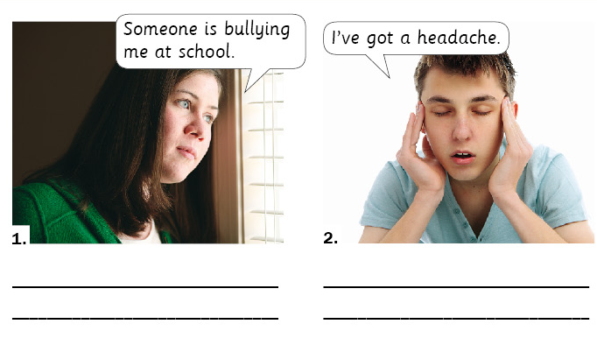

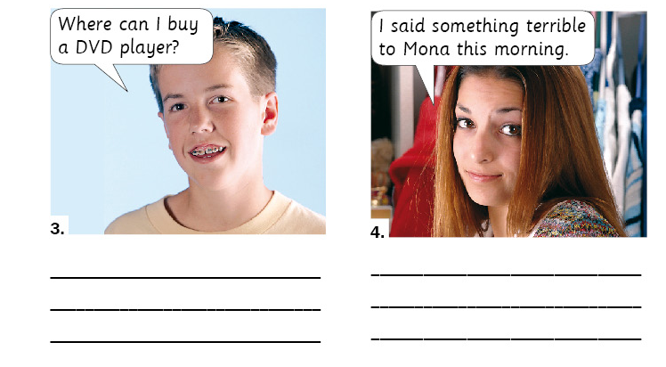

Read these situations and give an advice for each of them.
- I have a friend who is really tight-fisted. Every time that we go out for a drink or a meal he says he hasn’t got any money or he mysteriously disappears to the toilet when the bill arrives. At first we thought “poor John he never has any money”, but he works 6 days a week so he must have some money. What should we do?
______________________________________________________________________________________________________________________________________________________________________________________________________________________________________________________________________________
- My best friend is always flirting with my girlfriend. He always pays her lots of compliments like “Wow! You look fantastic tonight!” Also when we go to parties he often asks her to dance. It’s making me really angry. What should I do?
______________________________________________________________________________________________________________________________________________________________________________________________________________________________________________________________________________
- I share a flat with a friend and she keeps borrowing my things without asking. At first it was just little things like books and DVDs but now she’s started borrowing my clothes and when I want to wear my favorite dress for example, I find it on her bedroom floor unwashed! What should I do?
______________________________________________________________________________________________________________________________________________________________________________________________________________________________________________________________________________

Discussion questions for first situation:
- Do you have any tight-fisted friends?
- What do they do?
- What is the custom when it comes to paying the bill in your country?
- Have you ever had an argument over a restaurant bill?
Second
- Who has a problem in this situation?
- Is the speaker right to feel angry?
- Who is to blame for the anger?
- Have you or any of your friends ever been in this situation?
- Are you a jealous person?
Third
- Have you ever been in a situation like this?
- Do you lend things to friends? Why? Why not?
- Do you borrow things from friends? Why? Why not?
- Have you ever lived in a shared house? What problems did you encounter?

Exercise 1

Change the words in brackets into their correct form :
- If you ______________ interrupting me the whole time, I would have enjoyed the movie. (be)
- If I had had your number, I _____________________ you. (phone)
- They _____________________ that route if they had known that there were road works. (take)
- I wouldn’t have booked that holiday if I ______________ there was a cheaper deal. (know)
- If I _________________ my job, I wouldn’t have moved to London. (lose)
- I ________________ used Groupon if I had known that it existed. (have)
- If I had seen the weather forecast, I _________________ an umbrella. (pack)
- If the weather ________________better yesterday, I would have gone for a swim. (be)

Exercise 2
Complete these situations with a third conditional in your own words.
- ….. I would have been happier
- If I had been born in the 19th century…..
- If I had been an only child…..
- …..the world would have been a better place.
- If Superman had been a girl….
- If the 2nd World War hadn’t happened….
- …..I would have been a supermodel.
- …..I wouldn’t have got an education.

Exercise 3
The students need to write down 5 regrets that they have.
_______________________________________________________________________________________________________________________________________________________________________________________________________________________________________________________________________________________________________________________________________________________________________________________

Exercise 4
You have a scenario where something has gone wrong. You have to write what would happened using third conditional.
e.g. You locked yourselves out of the house.
If you had reminded me to take my keys, we wouldn’t be stuck outside.
If you hadn’t been in such a rush, I wouldn’t have run out in such a hurry.
If you had put the keys where they should have been, I would have seen them. etc etc

Possible scenarios:
You can’t remember where you put your English notebook.
You got lost.
You missed a conference about university apllication.
You overslept.
You failed an exam.
______________________________________________________________________________________________________________________________________________________________________________________________________________________________________________________________________________________________________________________________________________________________________________________________________________________________________________________________________________________________________________________________________________________________________________________________________________________________________________________________________________________________________________________________________________________________________________

